**Assignment on Optionals and Enumerations**

1. Imagine you have an app that asks the user to enter his/her age using the keyboard. When your app allows a user to input text, what is captured for you is given as a

`String`. However, you want to store this information as an `Int`. Is it possible for the user to make a mistake and for the input to not match the type you want to store?

Ans:

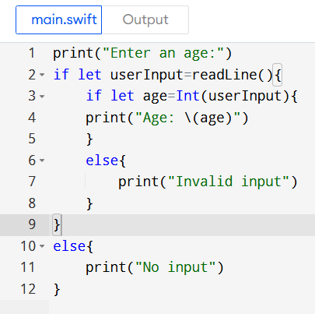

Output:

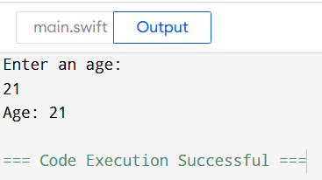

1. Declare a constant `userInputAge` of type `String` and assign it "34e" to simulate a typo while typing age. Then declare a constant `userAge` of type `Int` and set its value using the `Int` initializer that takes an instance of `String` as input. Pass in

`userInputAge` as the argument for the initializer. What error do you get?

Ans:

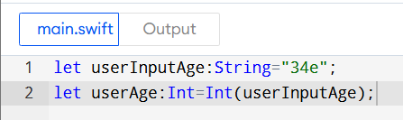

Output:

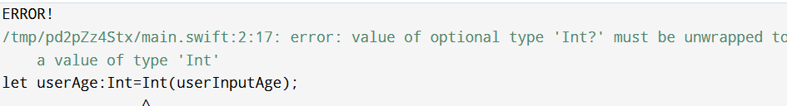

Error is raised because the valur of userInoutAge is not an valid int to which we represents in string so that the error is occurred while we are trying to convert the String into Int.

1. Go back and change the type of `userAge` to `Int?`, and print the value of `userAge`. Why is `userAge`'s value `nil`? Provide your answer in a comment or print statement below.

Ans:

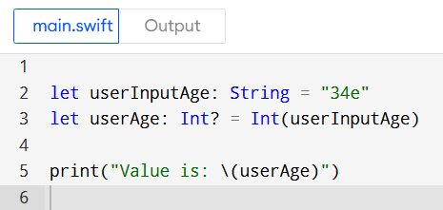

Output:

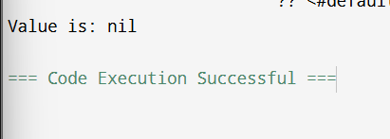

**Justification:**

Here in this output the value of the userAge is nil because we use failable initializer .it attempt to covert or wrap a string “34e” into Int but it not valid . so tha the initializer fails and returns nil when it encounter an invalid input.

1. Now go back and fix the typo on the value of `userInputAge`. Is there anything about the value printed that seems off? Print `userAge` again, but this time unwrap `userAge` using the force unwrap operator.

Ans:

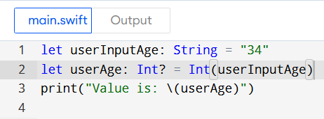

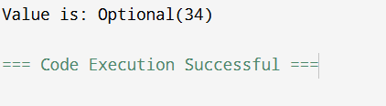

1. Now use optional binding to unwrap `userAge`. If `userAge` has a value, print it to the console.

Ans:

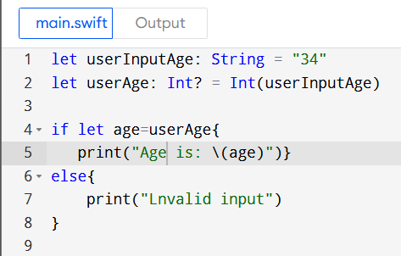

Output:

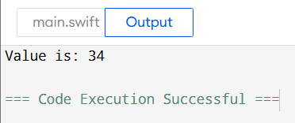

## App Exercise - Finding a Heart Rate

1. Many APIs that give you information gathered by the hardware return optionals. For example, an API for working with a heart rate monitor may give you `nil` if the heart rate monitor is adjusted poorly and cannot properly read the user's heart rate. Declare a variable `heartRate` of type `Int?` and set it to `nil`. Print the value.

Ans:

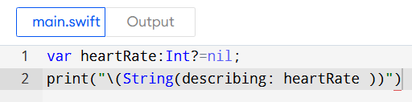

Output:

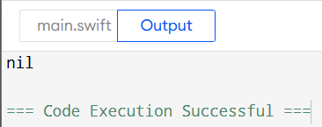

1. In this example, if the user fixes the positioning of the heart rate monitor, the app may get a proper heart rate reading. Below, update the value of `heartRate` to 74. Print the value.

Ans:

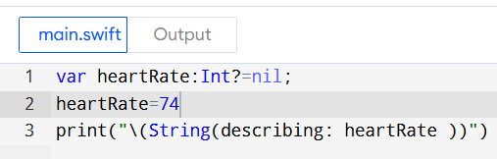

Output:

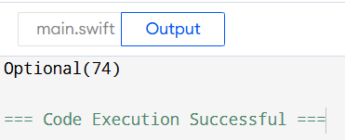

1. As you've done in other app exercises, create a variable `hrAverage` of type `Int` and use the values stored below and the value of `heartRate` to calculate an average heart rate.

let oldHR1 = 80 let oldHR2 = 76 let oldHR3 = 79 let oldHR4 = 70

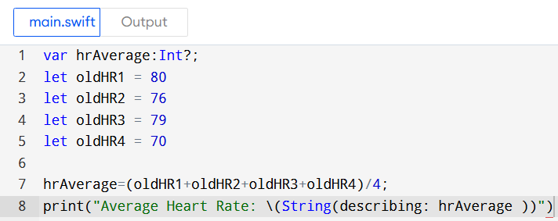

Output:

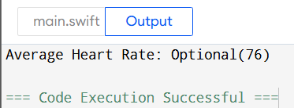

1. If you didn't unwrap the value of `heartRate`, you've probably noticed that you cannot

perform mathematical operations on an optional value. You will first need to unwrap

`heartRate`. Safely unwrap the value of `heartRate` using optional binding. If it has a value, calculate the average heart rate using that value and the older heart rates stored above. If it doesn't have a value, calculate the average heart rate using only the older heart rates. In each case, print the value of `hrAverage`.

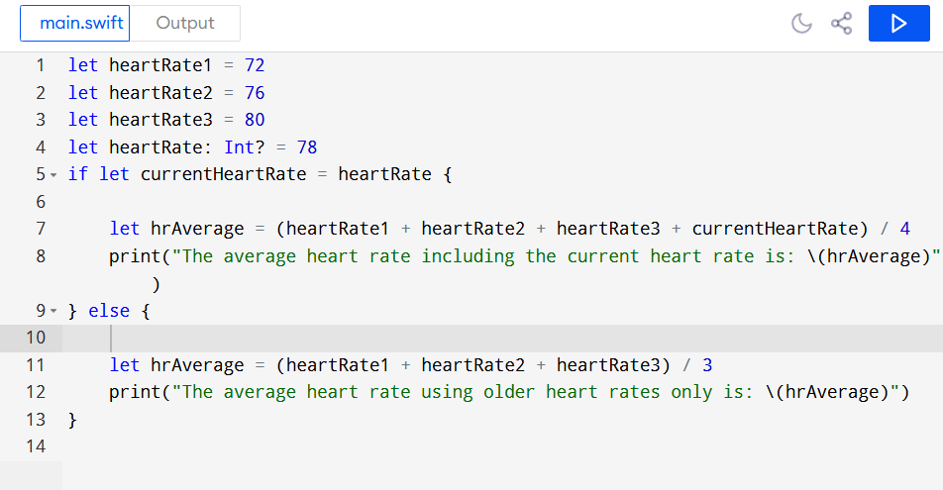

Ouptut:

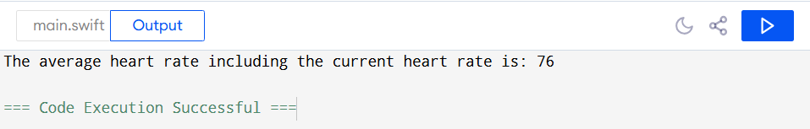

1. Define a `Suit` enum with four possible cases: `clubs`, `spades`, `diamonds`, and

`hearts`.

*/

Ans:

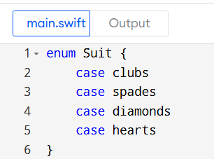

1. Imagine you are being shown a card trick and have to draw a card and remember the suit. Create a variable instance of `Suit` called `cardInHand` and assign it to the `hearts` case. Print out the instance.

Ans:

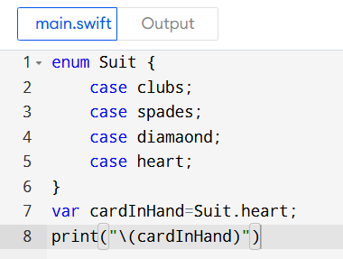

Output:

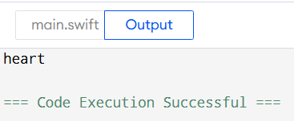

1. Now imagine you have to put back the card you drew and draw a different card. Update the variable to be a spade instead of a heart.

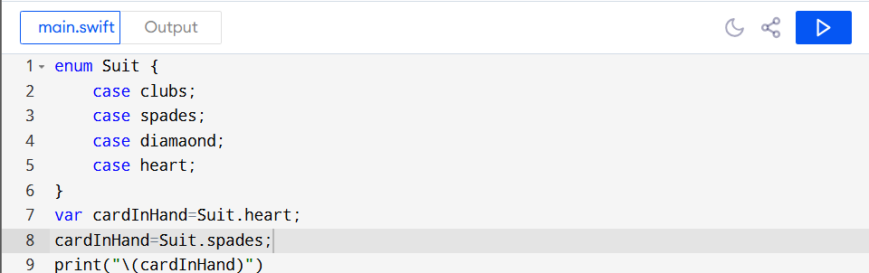

Output:

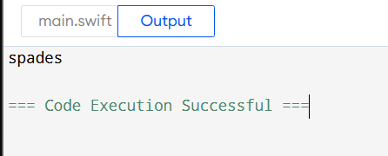

1. Imagine you are writing an app that will display a fun fortune (i.e. something like "You will soon find what you seek.") based on cards drawn. Write a function called

`getFortune(cardSuit:)` that takes a parameter of type `Suit`. Inside the body of the function, write a switch statement based on the value of `cardSuit`. Print a different fortune for each `Suit` value. Call the function a few times, passing in different values for `cardSuit` each time.

Ans:

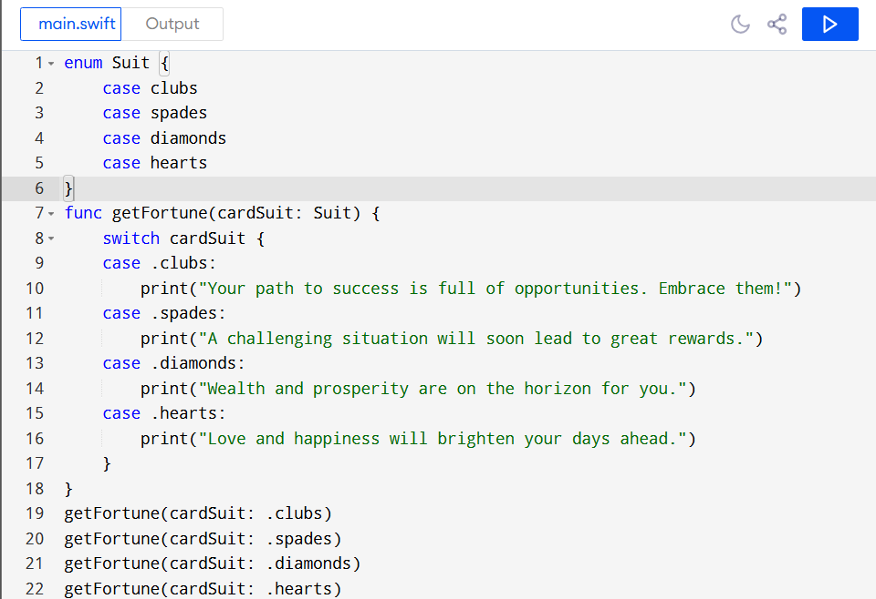

Output:

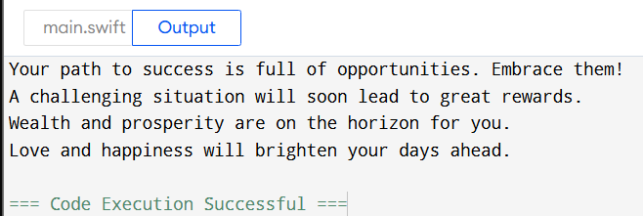

1. Create a `Card` struct below. It should have two properties, one for `suit` of type `Suit` and another for `value` of type `Int`.

Ans:

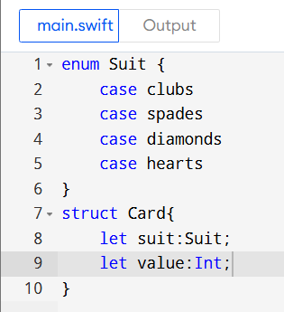

1. How many values can playing cards have? How many values can `Int` be? It would be safer to have an enum for the card's value as well. Inside the struct above, create an enum for `Value`. It should have cases for `ace`, `two`, `three`, `four`, `five`, `six`,

`seven`, `eight`, `nine`, `ten`, `jack`, `queen`, `king`. Change the type of `value` from

`Int` to `Value`. Initialize two `Card` objects and print a statement for each that details the card's value and suit.

Ans:

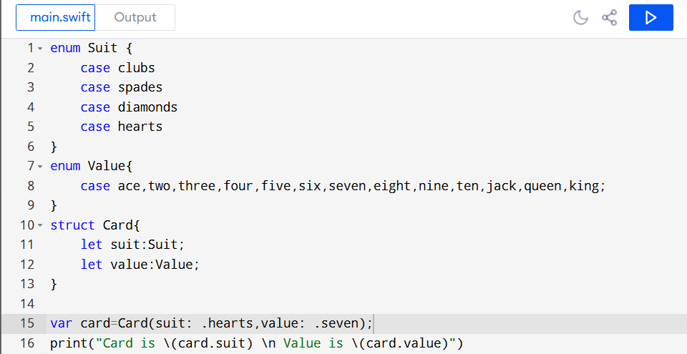

Output:



